Leapfrog Technology
Charkhal Rd, Kathmandu 44605

Assignment 1: Git basics

Submitted by Submitted to
Name: Sushant Dotel Ram Bhandari
Roll No: 7
1. Can we have a global .gitignore ?
Ans: Yes we can create a global .gitignore file in home directory and configure git to use that file as global .gitignore using following command:
git config --global core.excludesfile ~/.gitignore

2. How to find difference between two branches?
Ans: If there are two branches english and nepali,
git diff nepali english
shows changes between the heads of nepali and english branch. It basically shows what has changed in the english branch compared to the nepali branch. This is analogous to git diff english..nepali.
Following example illustrates a usage:
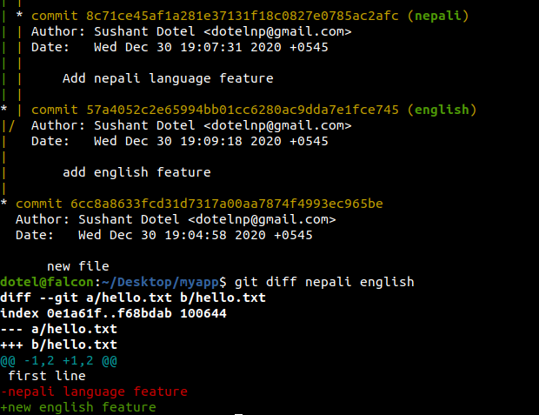

But it’s a little different from git diff english nepali which means difference in nepali branch head compared to english branch head.

Also, there’s git diff nepali...english which compares the merge-base of nepali and english branch with the english branch. In the following example, the merge base of nepali and english branch is the commit 6cc8a so the changes in head of english branch compared to commit 6cc8a is displayed. It is analogous to git diff ${git merge-base nepali english} english
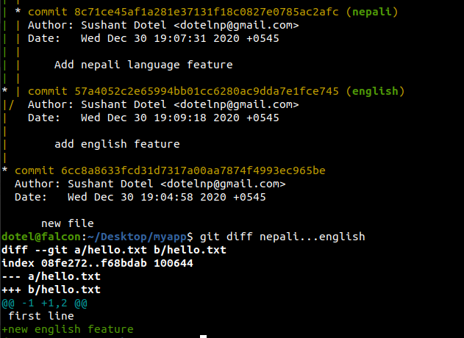

3. How to find difference between two commits?
Ans: Continuing the context of above running example, what has changed in the commit with commit message “add english feature” compared to the commit with commit message “new file” can be displayed by the command
git diff 6cc8a86 57a4052
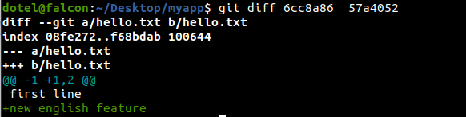
4. How to find change of a file between two commits?
Ans: Continuing the context of above running example, the difference between hello.txt file of two trees with commit message “new file” and “add english feature” can be displayed by
git diff 57a4052 6cc8a86 hello.txt
The output will be the same as git diff 57a4052 6cc8a86 in this running example since hello.txt is the only file being tracked.

5. How to find change of a file between two branches?
Ans: The difference between hello.txt file of the heads of two branches english and nepali can be displayed by
git diff english nepali hello.txt

